ALHOA MEMBER ANNUAL MEETING – THURSDAY, OCT. 12, 2017

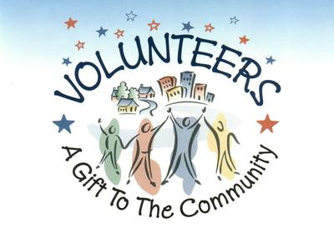

OUR COMMUNITY OFFERS MANY OPPORTUNITIES TO VOLUNTEER

BOARD OF DIRECTORS: The Board of Directors manage the affairs of the Association and is comprised of no fewer than three (3) and no more than seven (7) Directors. Members serve a three (3) year term. The current Board consists of (5) members – the terms of two of those five members expire October, 2017. There is also a possibility an additional member will resign for personal reasons. The Board meets once a month and meetings are approximately 2-2 ½ hrs in length. There is no better time than NOW for YOU to become a member of the ALHOA Board. Contact the office, 751-0976, for additional information.

STRATEGIC PLANNING COMMITTEE: The Committee investigates options and establishes timelines for improvements based upon budgets and the needs of the Association.

SOCIAL COMMITTEE: The Social Committee plans and hosts events that provide an excellent opportunity for members to socialize and meet one another. The Committee hosts both family and adult events and is in dire need of younger members to assist in planning and hosting events designed specifically for families and children, i.e Easter Egg Hunt, Memorial Day and Halloween.

NEIGHBORHOOD WATCH COMMITTEE: Organize and set up Block Captains to assist in informing the neighborhood about safety awareness, vandalism and to assist in prevention of future instances of crime.

FINANCIAL COMMITTEE: Review financial statements, balance sheets, and all expenditures of the Association to provide assistance to the Board of Directors in making financial decisions throughout the fiscal year. In addition, the Committee assists in preparing an annual budget to be submitted to the Board of Directors prior to the annual meeting for approval.

THE PROCES IS EASY, SIMPLY SUBMIT YOUR NAME TO OUR OFFICE ADMINISTRATOR, MARY WILLIAMS, 751-0976 OR alhoalanding@comcast.net

DON’T BE A “MOLLY SIDE LINER” GET INVOLVED, THERE’S MUCH TO DO AND MANY HANDS ARE NEEDED!!!

